**Conference Management System (CMS)**

**Documentation**

**Presentation of the application**

**ConferenceDetails Form**

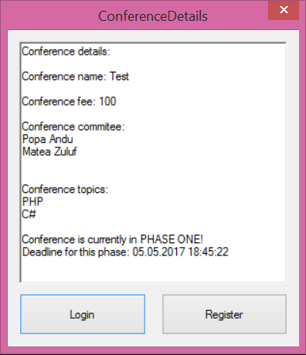

This form displays information about a conference.

**Register Form**

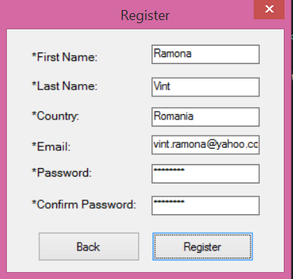

We have a register form connected to a PreliminaryPhaseController that enables user registration.

Once the account is validated, the submitter logins, submits the abstract and fulfills the meta-information required: the name of the proposal, the keywords, the topics, the possible list of authors and their meta-information.

A chair is NOT allowed to submit proposals.

**Login Form**

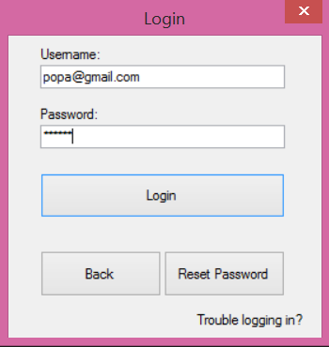

**UserAccount Form** 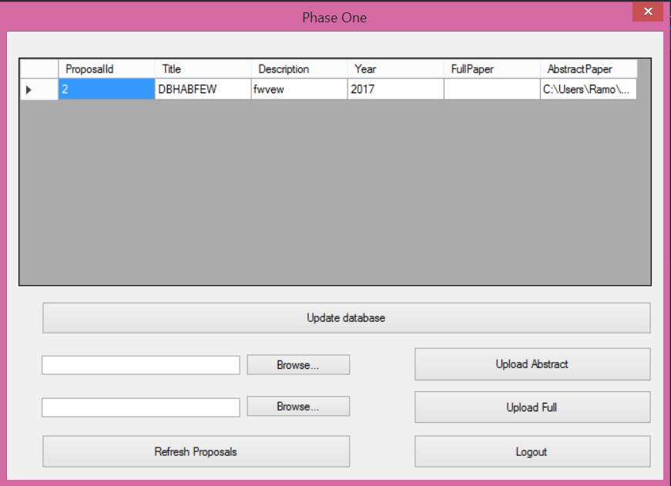

**ChairMain Form**

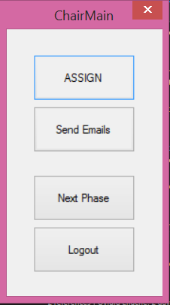

Chairs can assign to each reviewer the papers required to be evaluated. The authors will be announced by email about their results.

**ChairAssignementToReviewer Form**

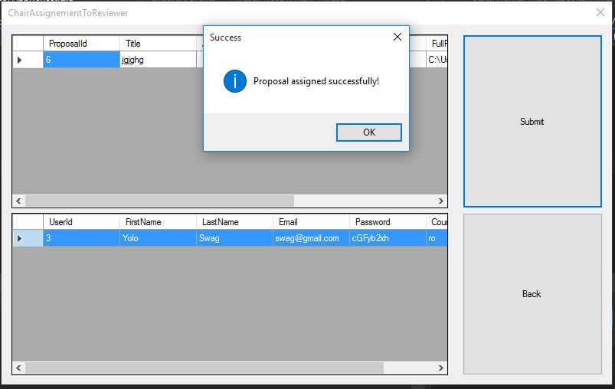

YOU MUST select the entire row for the reviewer.

In the second phase, PC members are required to bid the proposals. We did this with another form.

**PCMemberBidProposals Form**

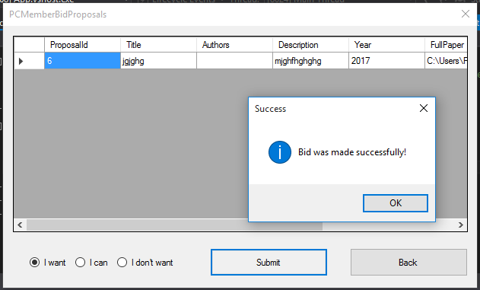

Each PC member has to do a brief analyze of abstracts or papers in order say if :

* they are pleased to review some papers
* they are could evaluate some papers
* they refuse to evaluate other papers.

Once the bidding process closed (there is a deadline for bidding), the conference chair or co-chairs assign to each reviewer the papers required to be evaluated.

The result of each reviewer carries one of the following qualifiers: strong accept, accept, weak accept, borderline paper, weak reject, reject and strong reject. The papers whose evaluation does contain any level of reject are accepted by default.

**PCMemberRateProposals Form**

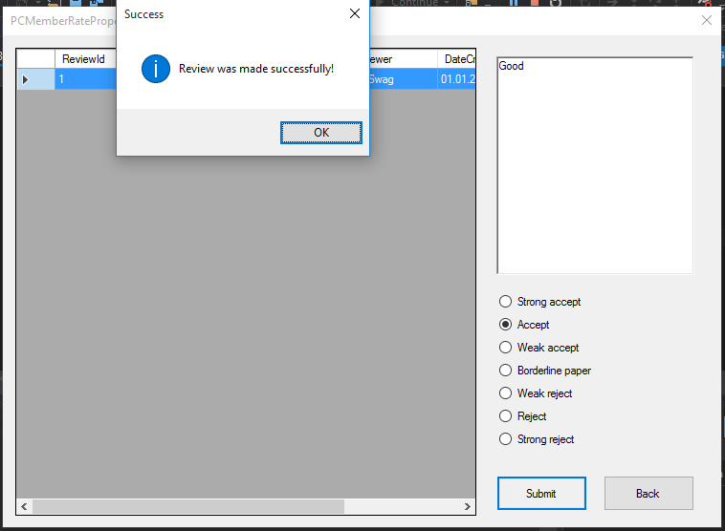

Submissions having been rated, the authors are notified via email about their results.

After that process we move to the third phase which concerns the conference activities.

In the third phase the application manages the schedule or other functionalities that makes easier for people to attend the event.

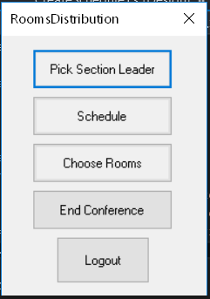

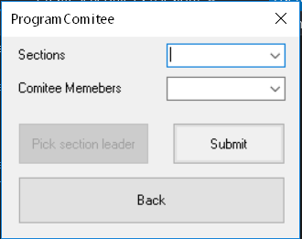

Each section is led by one of the Comitee Members (Not an author of the Conference) The Chair picks a leader for each section.

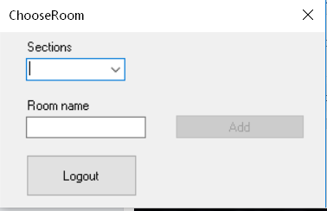

Each section takes place in one of the available rooms and the chair is responsable for choosing the room for each section.

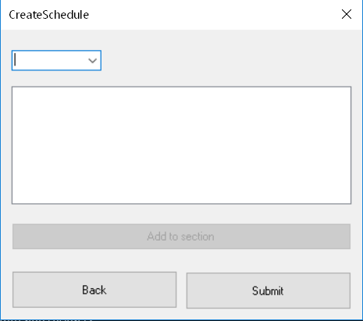

Each proposal is selected to be a part of a section and the datetime is required for it.The proposal can only be presented in one section.

**Team structure**

We worked on four phases, each phase with its corresponding team: a team for front-end, a team for back-end, a team for the tests (testing) and a team for reviewing code.

Each member had the opportunity to work in front-end and back-end teams but only a few had the opportunity to work in the team that reviewed code.

The front-end team’s main task was to present and put data or relationships in context for a good interaction between the application and the client making things look good, as good-looking things sell better.

The back-end team was the team who created logical back-end and core computational logic of a software or information system. The team created components and features that are indirectly accessed by a user through the front-end’s work.

**GIT**

We used GIT for tracking changes in the application and coordinating work amongst the team members.

Every GIT directory on every computer is a full-fledged repository with complete history and full version tracking abilities, independent of network access or a central server.

We cloned the repository from <https://github.com/ovidiuenache/iss-project> . The project was equally split between the team members. Each member worked on his part of the project and after that the content was pushed on GIT for all the members to see the changes.

**Trello**

Trello is a collaboration tool that organizes your projects into boards. In one glance, Trello tells you what is being worked on, who is working on what, and where something is in a process.

It made it easier for us to assign each team and its members a task and a deadline and we could supervise every process and the way members deal with given tasks.

**IDE**

One of the first steps we took in approaching this project was chasing the tools. This led to the ultimate decision of using Visual Studio as IDE, C# as language supported by .NET framework.

Firstly, we chased Visual Studio for being a tremendous IDE which enables easier app development for any platform in all languages, also taking into consideration its extensions which facilitate code writing in a great measure.

**Programming language and Framework**

In terms of framework and language we chased NET C#. It was a decision taken by all the members who have expressed their wish through voting, a decisive factor being the fact that it was the most popular language between us. In addition, the documentation offered by Microsoft was a great aid. Being highly elaborated and extremely well organized, it helped us find solutions to our answers and queries very fast.

The .NET Framework provides a comprehensive programming model which enables creating all kinds of applications that work for Windows being convenient for mobile, web and even for desktop.

The easiness in working with windows forms and the familiarity of the members with this type of applications were key factors that ultimately led to the decision of designing a desktop application. The decision was the most clever one because it helped us save time and avoid future misunderstandings and conflicts between the members.

When we saw the final result, everyone was pleased for having made this first decision as a team.

**What We Would Like to Change**

The application is subject to change as we would like to convert it into a web application. We want to make it portable and easy to use for phones and tablets.